Program-1 led blinking

int led =5;

void setup()

{

pinMode (led,OUTPUT );

}

void loop()

{

digitalWrite(led, HIGH);

delay(200);

digitalWrite(led, LOW);

delay(200);

}

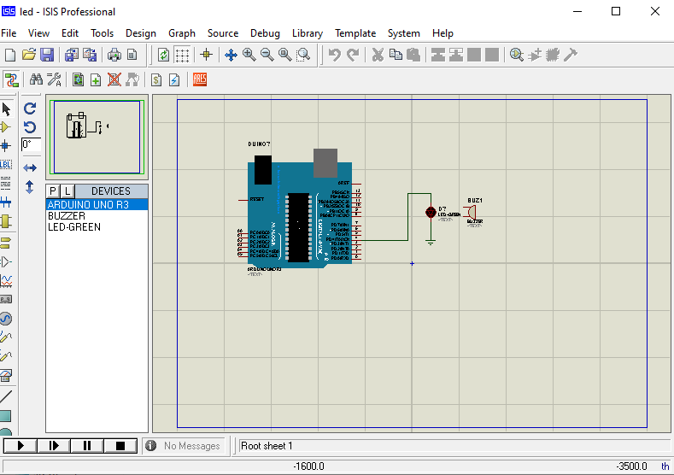

Program-2 switch

int switchPin = 2;

int ledPin = 13;

void setup() {

pinMode(ledPin, OUTPUT);

pinMode(switchPin, INPUT);

}

void loop()

{

if ( digitalRead(switchPin) == HIGH )

{

digitalWrite(ledPin, HIGH);

}

else

{

digitalWrite(ledPin, LOW);

}

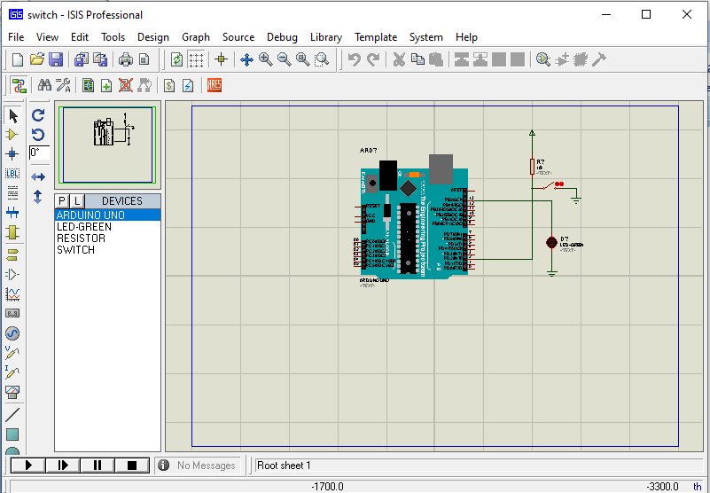}

Program-3 ambulance

int buzzer = 9;

void setup()

{

pinMode (buzzer ,OUTPUT);

}

void loop()

{

for (int i=0 ; i <= 255; i= i+ 5)

{

analogWrite(buzzer, i);

delay(30);

}

for (int i = 255; i >= 0; i=i-5)

{

analogWrite(buzzer, i);

delay(30);

}

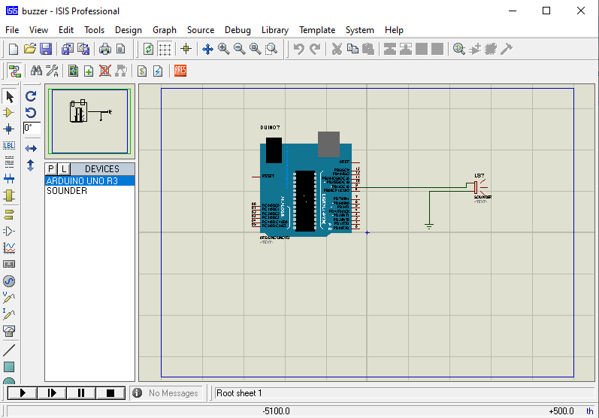}

Program-4 dc motor with fan

int motorpostitive =6;

int motornegative = 7;

void setup() {

pinMode(motorpostitive ,OUTPUT );

pinMode(motornegative ,OUTPUT );

}

void loop()

{

digitalWrite (motorpostitive ,HIGH);

digitalWrite (motornegative ,LOW);

delay(500);

digitalWrite (motorpostitive ,LOW);

digitalWrite (motornegative ,HIGH);

delay(500);

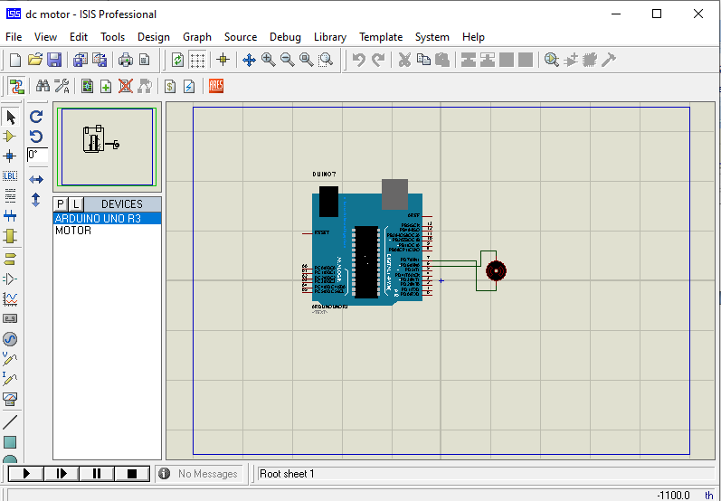 }

Program-5 dc motor with DRIVER

int motorpostitive =6;

int motornegative = 7;

void setup() {

pinMode(motorpostitive ,OUTPUT );

pinMode(motornegative ,OUTPUT );

}

void loop()

{

digitalWrite (motorpostitive ,HIGH);

digitalWrite (motornegative ,LOW);

delay(500);

digitalWrite (motorpostitive ,LOW);

digitalWrite (motornegative ,HIGH);

delay(500);

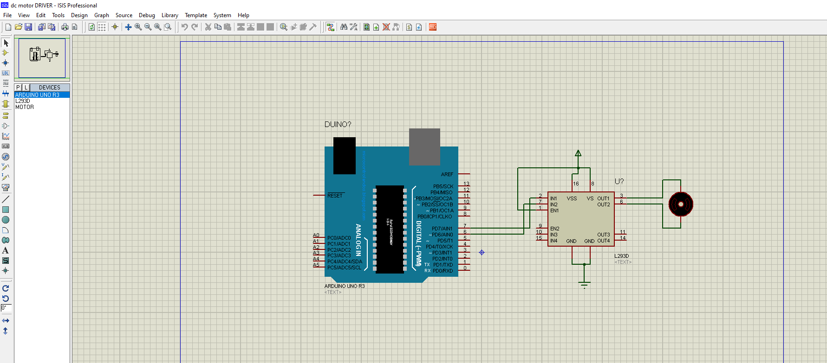 }

Program-6 car reverse sensor

int irsensor = 2;

int buzzer = 13;

void setup() {

pinMode(irsensor, INPUT);

pinMode(buzzer, OUTPUT);

}

void loop()

{

if ( digitalRead(irsensor) == HIGH )

{

digitalWrite(buzzer, HIGH);

}

if ( digitalRead(irsensor) == LOW )

{

digitalWrite(buzzer, LOW);

}

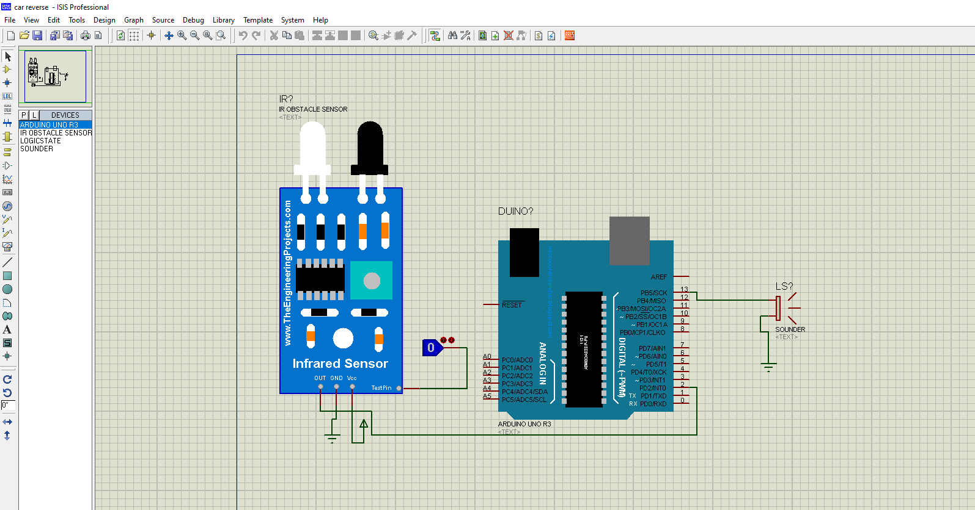}

Program-7 ir with motor

int irsensor =5;

int motorpostitive =6;

int motornegative = 7;

void setup()

{

pinMode( irsensor ,INPUT );

pinMode(motorpostitive ,OUTPUT );

pinMode(motornegative ,OUTPUT );

}

void loop()

{

if (digitalRead(irsensor)== HIGH)

{

digitalWrite (motorpostitive ,HIGH);

digitalWrite (motornegative ,LOW);

}

if (digitalRead(irsensor)== LOW)

{

digitalWrite (motorpostitive ,LOW);

digitalWrite (motornegative ,LOW);

}

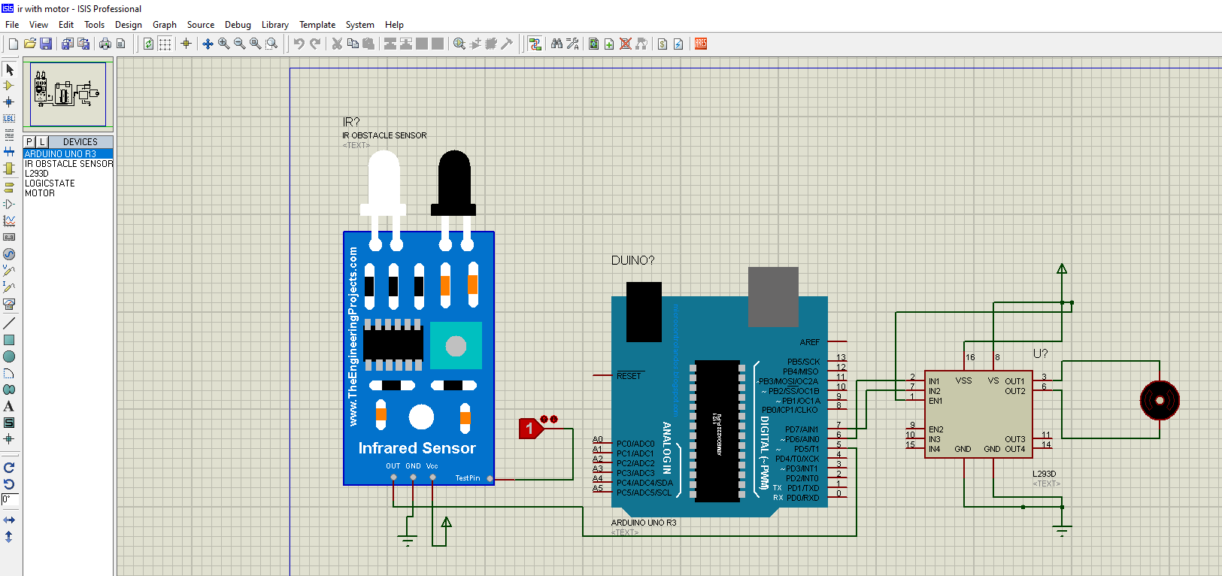}

Program-8 Ldr

int buzzer = 11;

void setup()

{ pinMode(buzzer,OUTPUT);

}

void loop()

{

int LDR = analogRead(A0);

delay(500);

if(LDR > 512)

{

digitalWrite(buzzer, HIGH);

delay(10);

}

else

{

digitalWrite(buzzer, LOW);

delay(10);

}

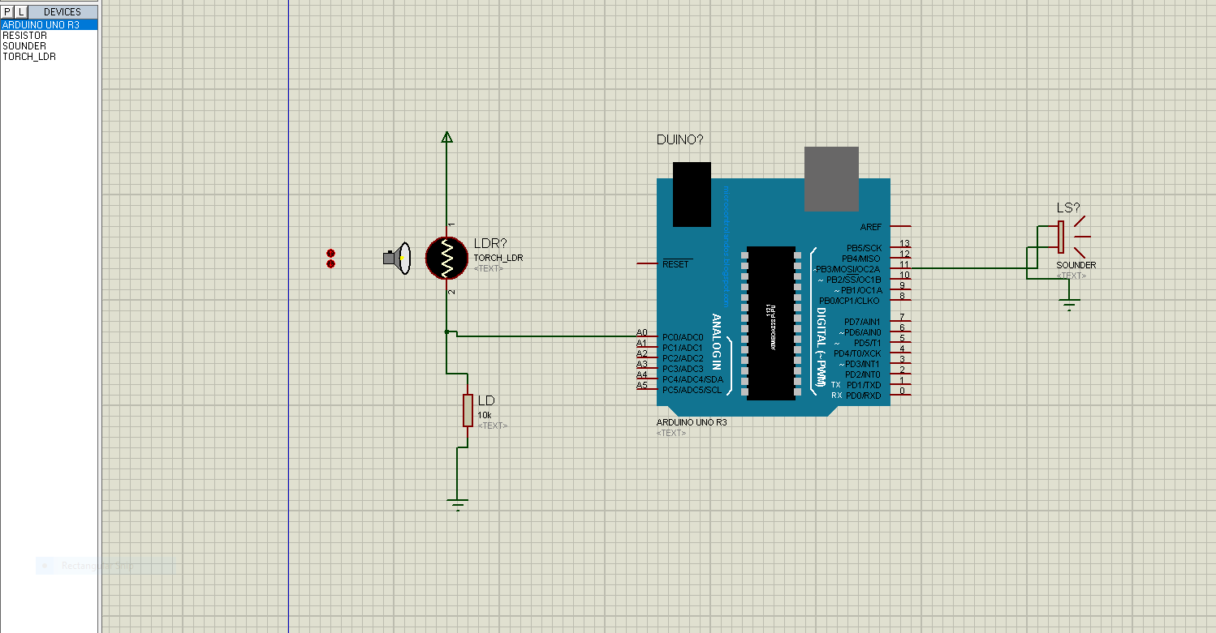 }

Program-9 temp- love o meter

int red = 8;

int yellow = 9;

int green = 10;

int tempsensor= A0;

void setup()

{

pinMode(red,OUTPUT);

pinMode(yellow,OUTPUT);

pinMode(green,OUTPUT);

pinMode(tempsensor,INPUT);

}

void loop()

{

int temp = analogRead(tempsensor);

if(temp < 100 && temp >1 )

{

digitalWrite(red, HIGH);

digitalWrite(yellow, LOW);

digitalWrite(green, LOW);

}

if(temp < 200 && temp >101)

{

digitalWrite(red, LOW);

digitalWrite(yellow, HIGH);

digitalWrite(green, LOW);

}

if(temp <300 && temp >201)

{

digitalWrite(red, LOW);

digitalWrite(yellow, LOW);

digitalWrite(green, HIGH);

}

}

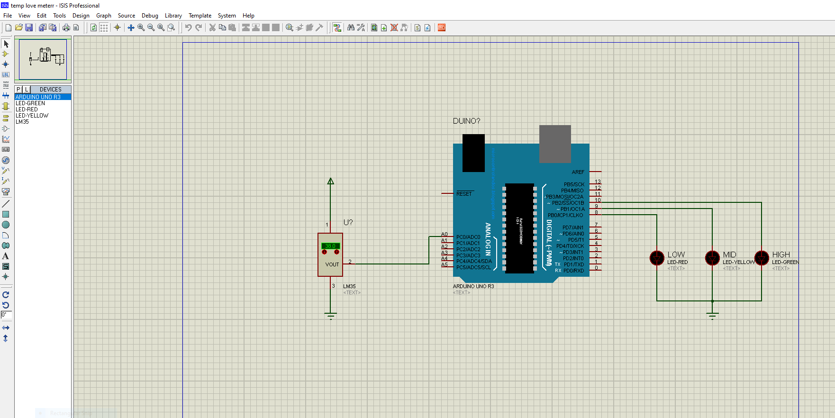

Program-10 task1- line follower robot

int leftsensor = 2;

int rightsensor = 3;

int leftmotorpositive = 8;

int leftmotornegative= 9;

int rightmotorpositive =10;

int rightmotornegative = 11;

void setup() {

pinMode(leftmotorpositive, OUTPUT);

pinMode(leftmotornegative, OUTPUT);

pinMode(rightmotorpositive, OUTPUT);

pinMode(rightmotornegative, OUTPUT);

pinMode(leftsensor, INPUT);

pinMode(rightsensor, INPUT);

}

void loop() {

if (digitalRead(leftsensor)== HIGH && digitalRead(rightsensor) == HIGH)

{

digitalWrite(leftmotorpositive, HIGH);

digitalWrite(leftmotornegative, LOW);

digitalWrite(rightmotorpositive, HIGH);

digitalWrite(rightmotornegative, LOW);

}

if (digitalRead(leftsensor)== LOW && digitalRead(rightsensor) == HIGH)

{

digitalWrite(leftmotorpositive, LOW);

digitalWrite(leftmotornegative, LOW);

digitalWrite(rightmotorpositive, HIGH);

digitalWrite(rightmotornegative, LOW);

}

if (digitalRead(leftsensor)== HIGH && digitalRead(rightsensor) == LOW)

{

digitalWrite(leftmotorpositive, HIGH);

digitalWrite(leftmotornegative, LOW);

digitalWrite(rightmotorpositive, LOW);

digitalWrite(rightmotornegative, LOW);

}

if (digitalRead(leftsensor)== LOW && digitalRead(rightsensor) == LOW)

{

digitalWrite(leftmotorpositive, LOW);

digitalWrite(leftmotornegative, LOW);

digitalWrite(rightmotorpositive, LOW);

digitalWrite(rightmotornegative, LOW);

}

 